A Quick Look at Redlining – Comparison between HOLC Designations and 2020 Census Data
By Olga Ivashyna
(ECO4443 - Spring 2026)

Introduction:
Redlining has had a vast impact on the history of the United States and on the current demographics. For those uninitiated, redlining can be defined as the real estate practice of assigning areas or neighborhood with a four-letter system (from “A” for “Best” to “D” for “Hazardous”) and using that system as a mechanism of essentially assigning people of different races to different areas, with the end result being that racial minorities ended up living in worse areas.
There are two datasets that will be analyzed over the course of this paper. The first dataset (metro-grades) involves variables such as the name of the area, the grade level of the area assigned by the Home Owners' Loan Corporation (HOLC), the number, percentages and location quotient (defined by the Mapping Inequality Project as “...small-area measures of segregation that specifically compare one racial/ethnic group’s proportion in a granular geography to their proportion in a larger surrounding geography. An LQ above 1 for a given racial group indicates overrepresentation in that HOLC zone relative to the broader surrounding area, and values below 1 indicate underrepresentation ”) of different areas, and the percentages of different racial groups living in surrounding areas. The second dataset(zone-block-matches) has more categorical variables such as the HOLC ID, the state, and the percentage line-up between the 2020 US Census racial demographic and the racial demographics at the power of the HOLC’s influence.
The questions this paper is interested in asking as follows: can the racial demographics of an area be predicted based on the HOLC grade of an area and those surrounding it, and is there a significant overlap in racial compositions between 2020 and the time of the HOLC’s peak? The outcome variable for the first question will be the percentages of different races living in an area and the paper will be using the percentages of surrounding areas and the HOLC grade as the predictors. The second question will being looking into the outcome of the 2020 percentage comparison using he percentages of surrounding areas, the HOLC grade and the location quotient and the as predictors.

Link to the initial datasets (read: unaltered): https://github.com/fivethirtyeight/data/tree/master/redlining

Descriptive Analysis:
Metro-grades has 27 total variables, including the name of the metropolitan area(metro_area), the HOLC grade given to an area(holc_grade), the white non-Hispanic population of the area(white_pop), the black population of an area(black_pop),the Hispanic population of an area(hisp_pop), the Asian population of an area(asian_pop), the population of other races in the area(other_pop), the total population of a HOLC area(total_pop), the percentage of white non-Hispanic people in an area(pct_white), the percentage of black people in an area(pct_black), the percentage of Hispanic people in an area(pct_hisp), the percentage of Asian people in an area(pct_asian), the percentage of other races in an area(pct_other), the location quotient of white people in an area(lq_white),the location quotient of black people in an area(lq_black), the location quotient of Hispanic people(lq_hisp), the location quotient of Asian people(lq_asian), the location quotient of other races(lq_other), non-Hispanic white population within surrounding area of a given metro area’s HOLC zones(surr_area_white_pop), non-Hispanic black population within surrounding area of a given metro area’s HOLC zones(surr_area_black_pop), Hispanic/Latino population within surrounding areaof a given metro area’s HOLC zones (surfr_area_hisp_pop), non-Hispanic Asian population within surrounding area of a given metro area’s HOLC zones(surr_area_asian_pop), population of other races within surrounding area of a given metro area’s HOLC zones(surr_area_other_pop), percentage of non-Hispanic white population within surrounding area of a given metro area’s HOLC zones(surr_area_pct_white), percentage of non-Hispanic black population within surrounding area of a given metro area’s HOLC zones (surr_area_pct_black), percentage of Hispanic/Latino population within surrounding area of a given metro area’s HOLC zones(surr_area_pct_hisp), percentage of non-Hispanic Asian population within surrounding area of a given metro area’s HOLC zones(surr_area_pct_asian), and the percentage of the population of other races within surrounding area of a given metro area’s HOLC zones(surr_area_pct_other).
Zone-block matches has seven total columns. This includes city name from this zone's HOLC map (holc_city), state abbreviation from this zone's HOLC map(holc_state), HOLC grade assigned to this zone(holc_grade), HOLC ID assigned to this zone(holc_id), Neighborhood ID from HOLC(holc_neighborhood_id), `GEOID20` of 2020 U.S. census block (block_geoid20), and the estimated percent of the 2020 U.S. census block's total area that intersects with a given HOLC zone(pct_match).
For metro-grades, the data can be gathered as follows:

 | Mean | Median | Std Dev
pct-white | 55.45245 | 59.01 | 22.47838
pct-black | 19.98296 | 13.39 | 18.66854
pct-his | 15.54083 | 8.8 | 16.86134
pct-asian | 3.231162 | 2.01 | 3.668255
pct-other | 5.792722 | 5.55 | 2.070412
white-lq | 1.050236 | 0.98 | 0.476836
black-lq | 1.042341 | 1.02 | 0.65246
his-lq | 1.024102 | 1 | 0.468835
asian-lq | 0.821506 | 0.74 | 0.425137
other-lq | 1.05167 | 1.05 | 0.200859
surr_area_white_pop | 54.77328 | 57.22 | 17.34471
surr_area_black_pop | 20.05102 | 16.55 | 15.19279
surr_area_his_pop | 15.58183 | 9.57 | 15.18811
surr_area_asian_pop | 4.080708 | 3.1 | 4.227148
surr_area_other_pop | 5.51323 | 5.31 | 1.773156

The distributions for each of the variables measured are as follows:
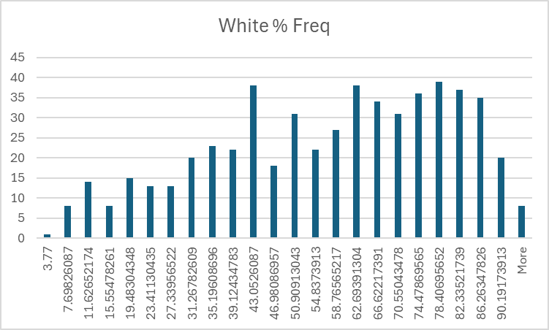
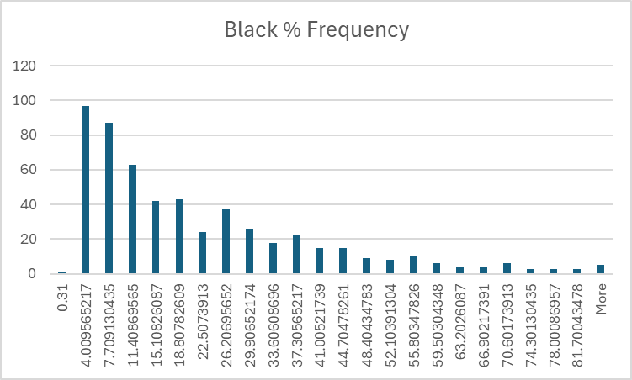

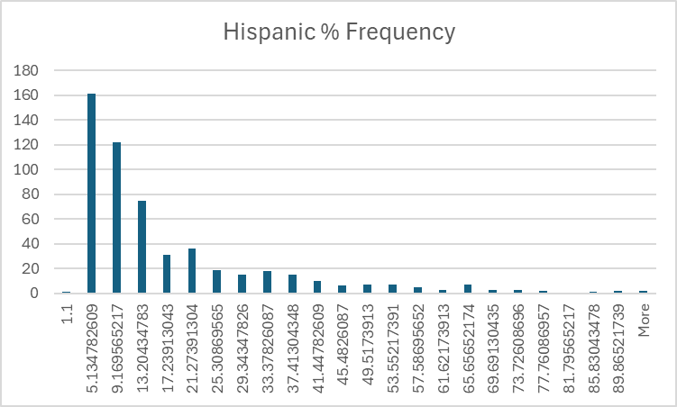
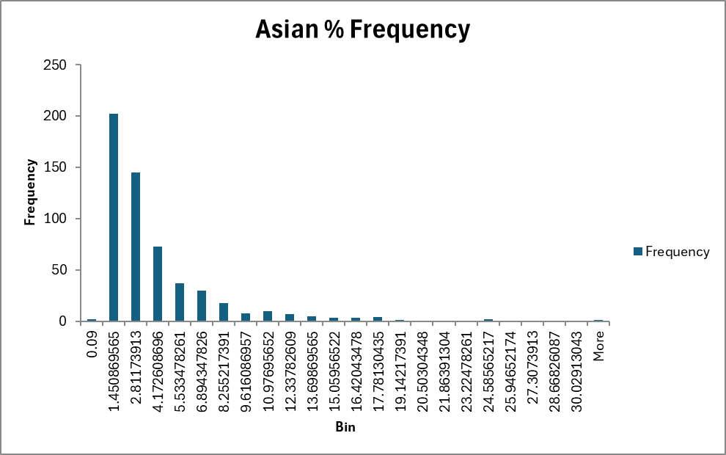

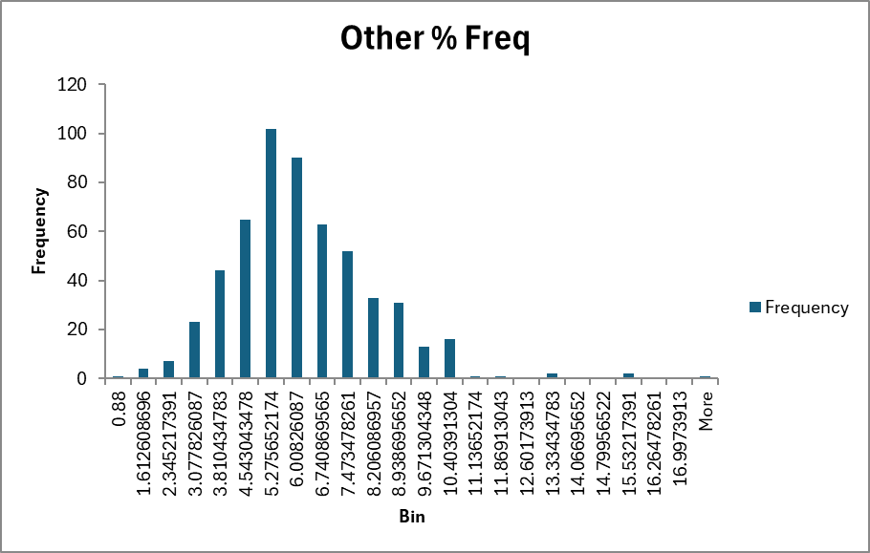
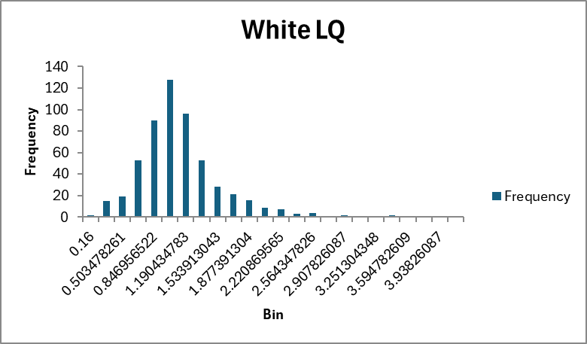

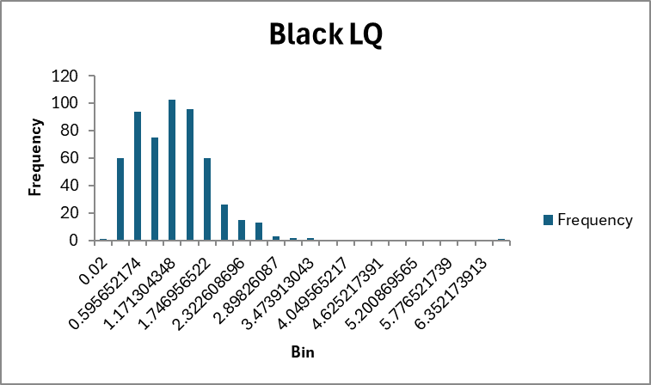
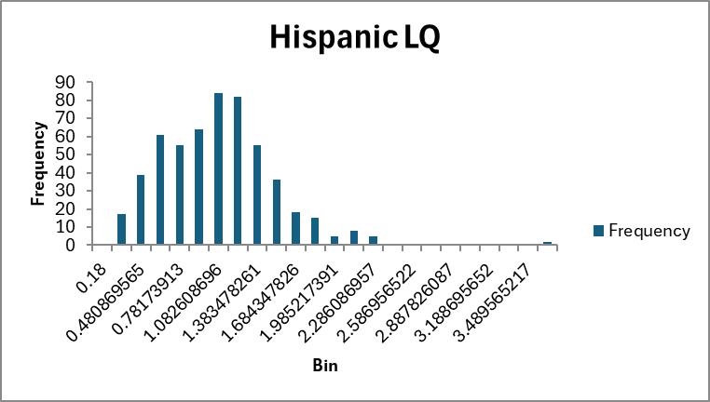

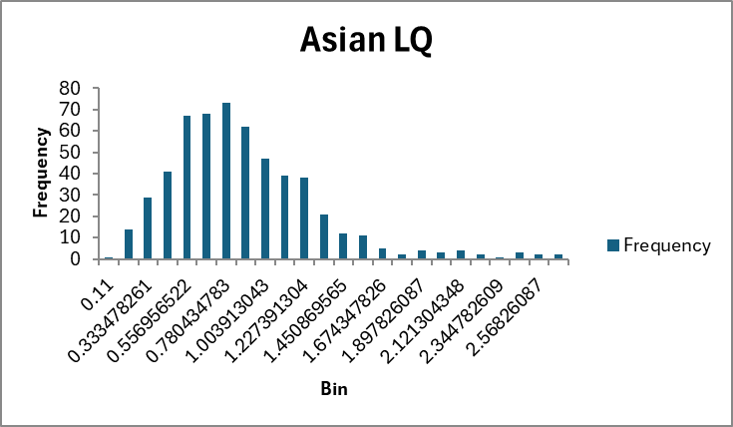
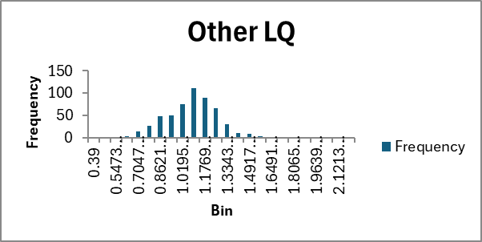

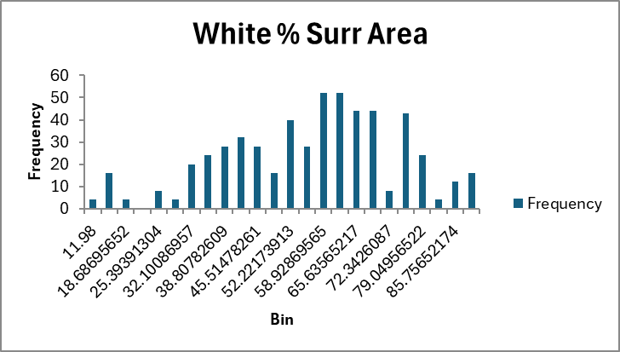
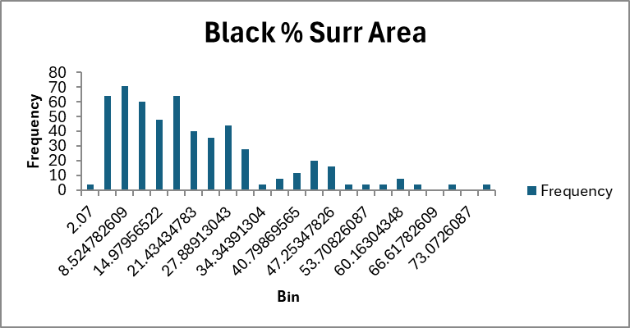

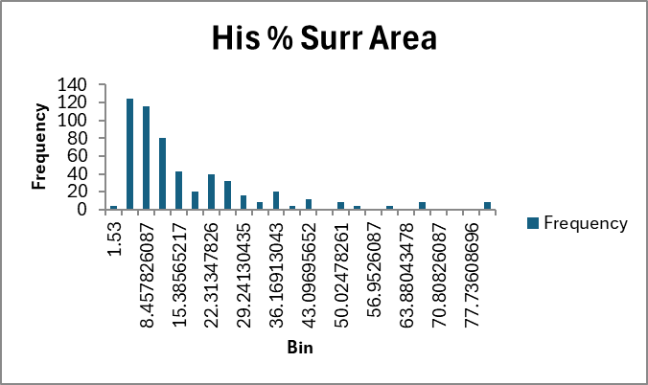
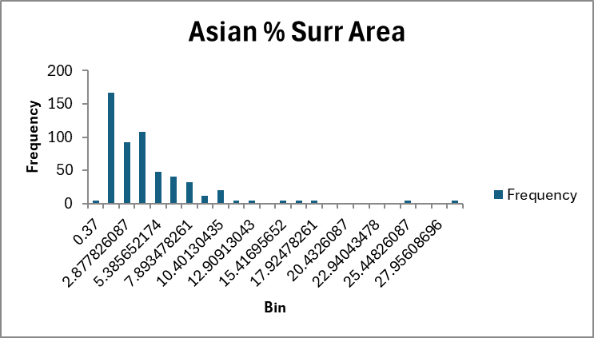

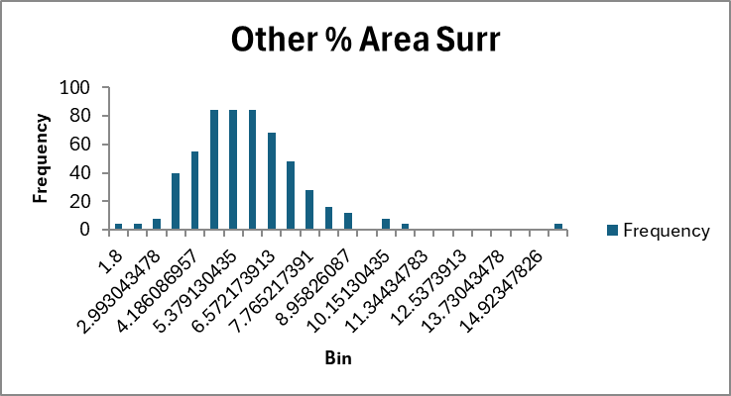

As is visible, the white population’s percentage and the white percentage in surrounding areas are much more spread out than other races. With the other percentage frequencies, save for the “Other” category, it can be argued that all other groups are skewed right, likely by virtue of the fact that on a national scale, there are considered minorities. The location quotients are generally normally distributed and on the smaller side of things, although the white location quotient has the strongest mean and the other race location quotient has the smallest range.

The second dataset where we’re testing the percentage match between the 2020 US Census is as follows:
Mean | Median | Std Dev
0.759316501 | 1 | 0.367086

The distribution is as follows:
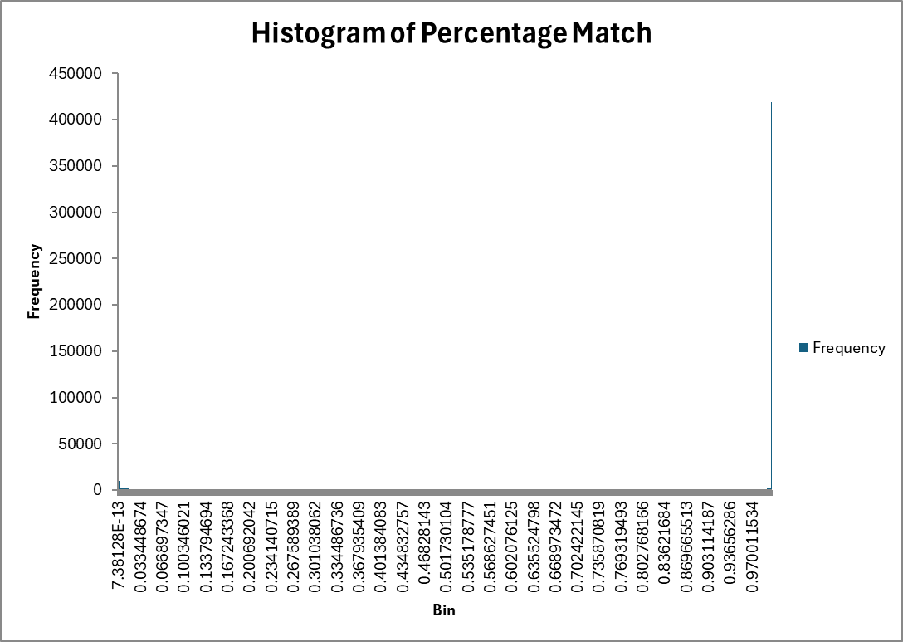

The distribution can be described as incredibly skewed-left, as a majority of the data points show that the block area show a 1-to-1 similarity between the area’s 2020 racial composition and the area’s racial composition during the peak of the HOLC. This would explain the significant difference between the mean and the median shown in the previous table.

Data Cleaning and Manipulation:
The biggest issue with comparing percentage-wise is that the zone-block-matches has information that splits the grades into neighborhoods that get ID’d, which gets further divided into the GEO Blocks of 2020 that were used in the 2020 Census. Because there is no comparison in the metro-grade file, the percentage will have to be merged if there are to be used at all. This will be done by deriving the average, the median, the 10% and 25% quartile to use for comparison and note effects. In a future project, it would be beneficial to find information that breaks down population moreso based on neighborhoods and potentially line them with the blocks of the 2020 census. Some cities will also be deleted in the zone-block-matches and metro-grades files as while the city may be listed in one file, it wasn’t listed in the other. This is potentially as a result of some cities not existing during the peak of the HOLC, or in the case of New York City, one file listed the whole city while the other lists the burroughs instead. This is stated to say that there is a potentially large effect from excluding New York City from the data and that should work like this be done in the future, it would be best to consolidate the percentages in some fashion to best characterize the whole city.
It will also service this paper to not use the columns that include absolute population. These were deleted in a data frame copy as they did not serve a purpose in this analysis, considering that something like city size would then need to be taken into account.
Lastly, models will be grouped by their HOLC grade to best categorize the effect of the grade on the racial composition of an area.

Visualizations:
Include and explain your graphs.

Statistical Analysis:
Detail your models, interpretations, and findings.

Conclusions:
Summarize key insights from your analysis.

